6.

insert into EMP(EMPNO,NAME,JOBNO,DEPTNO,COMM) values (10, 'CODD', 100, 50, NULL);

insert into EMP(EMPNO,NAME,JOBNO,DEPTNO,COMM) values (20, 'NAVATHE', 200, 50, 450);

insert into EMP(EMPNO,NAME,JOBNO,DEPTNO,COMM) values (30, 'ELMASRI', 300, 60, NULL);

insert into EMP(EMPNO,NAME,JOBNO,DEPTNO,COMM) values (40, 'DATE', 100, 50, NULL);

insert into JOB(JOBCODE, JOB_DESCR, SAL) values (100, 'SALESMAN', 2000);

insert into JOB(JOBCODE, JOB_DESCR, SAL) values (200, 'ANALYST', 2000);

insert into JOB(JOBCODE, JOB_DESCR, SAL) values (300, 'DBA', 3000);

insert into DEPT(DEPTNO, DNAME, LOC) values (50, 'SALES', 'ATHENS');

insert into DEPT(DEPTNO, DNAME, LOC) values (60, 'ACCOUNTING', 'ATHENS');

insert into DEPT(DEPTNO, DNAME, LOC) values (70, 'PAYROL', 'VOLOS');

9.

ALTER TABLE JOB MODIFY JOB_DESCR VARCHAR(30);

10.

ALTER TABLE DEPT DROP LOC;

11.

ALTER TABLE DEPT CHANGE DNAME DEPT_NAME VARCHAR(25);

12.

alter table DEPT add constraint pk_DEPTNO primary key (DEPTNO);

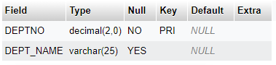

SHOW CREATE TABLE DEPT;

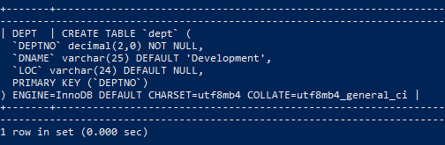

13.

ALTER TABLE DEPT DROP PRIMARY KEY;

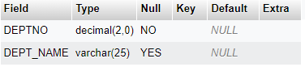

SHOW CREATE TABLE DEPT;

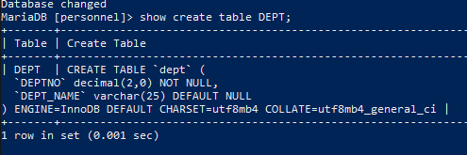

14.

ALTER TABLE JOB ADD CONSTRAINT PK_JOB PRIMARY KEY (JOBCODE);

DESCRIBE JOB;

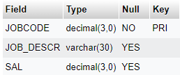

ALTER TABLE DEPT ADD CONSTRAINT pk_DEPTNO PRIMARY KEY (DEPTNO);

DESCRIBE DEPT;

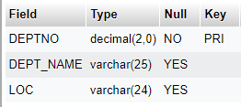

ALTER TABLE EMP ADD CONSTRAINT PK_EMP PRIMARY KEY (EMPNO);

ALTER TABLE EMP ADD CONSTRAINT FK_EMP1 FOREIGN KEY (JOBNO) REFERENCES JOB(JOBCODE);

ALTER TABLE EMP ADD CONSTRAINT FK_EMP2 FOREIGN KEY (DEPTNO) REFERENCES DEPT(DEPTNO);

DESCRIBE EMP;

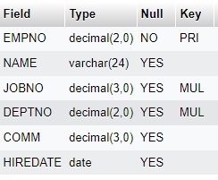

15.

ALTER TABLE EMP DROP FOREIGN KEY FK_EMP1;

DESCRIBE EMP;

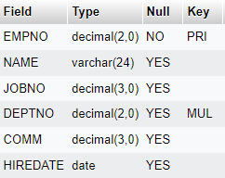

SHOW CREATE TABLE EMP;

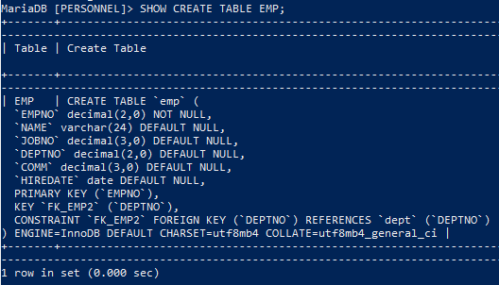

ALTER TABLE EMP DROP FOREIGN KEY FK_EMP2;

DESCRIBE EMP;

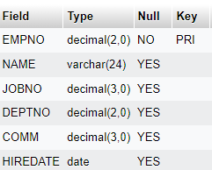

SHOW CREATE TABLE EMP;

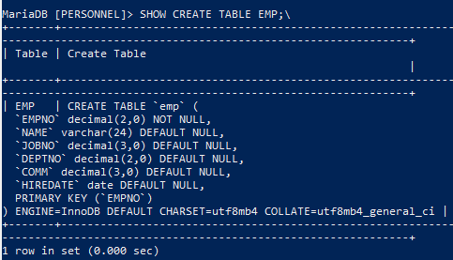

16.

ALTER TABLE DEPT ALTER DNAME SET DEFAULT 'Development';

insert into DEPT(DEPTNO) values (10), (20);

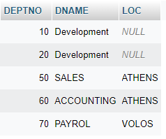

17.

select * from INFORMATION_SCHEMA.TABLE_CONSTRAINTS where CONSTRAINT_SCHEMA='personnel';

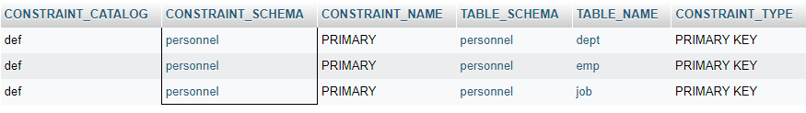

18.

CREATE TABLE PROJECT(

P_ID INT,

P_NAME VARCHAR(255));

ALTER TABLE PROJECT CHANGE P_ID P_ID INT NOT NULL AUTO_INCREMENT PRIMARY KEY;

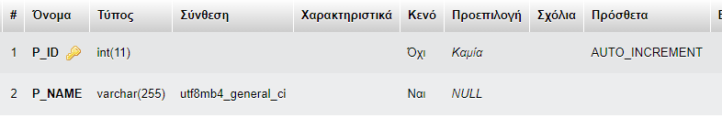

19.

INSERT INTO PROJECT(P_NAME) VALUES ('NIKOS');

SELECT * FROM PROJECT;



INSERT INTO PROJECT(P_NAME) VALUES ('THOMAS');

SELECT * FROM PROJECT;

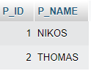

INSERT INTO PROJECT(P_NAME) VALUES ('21390068');

SELECT * FROM PROJECT;

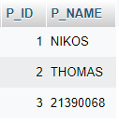

20.

ALTER TABLE PROJECT AUTO_INCREMENT = 200;

INSERT INTO PROJECT(P_NAME) VALUES ('NIKOS');

SELECT * FROM PROJECT;

INSERT INTO PROJECT(P_NAME) VALUES ('THOMAS');

SELECT * FROM PROJECT;

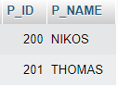

INSERT INTO PROJECT(P_NAME) VALUES ('21390068');

SELECT * FROM PROJECT;

